1) Create s3 bucket and upload some objects to s3.

2) Deploy static website in s3 bucket.

3) Enable cross region replication on s3 buckets.

4) Configure bucket policy,only Admin user can see the objects of s3 bucket.

5) Setup lifecycle policies to automatically transition or delete objects based on specific criteria.

6) Push some objects in s3 using AWS CLI.

7) Write a bash script to create s3 bucket.

8) Upload one 1 gb of file to s3 using cli.

1. Create s3 bucket and upload some objects to s3.

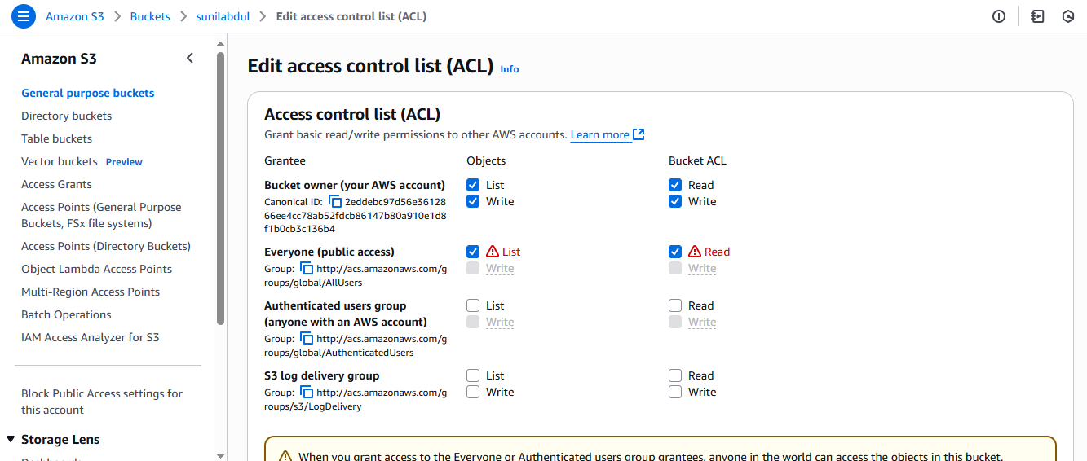

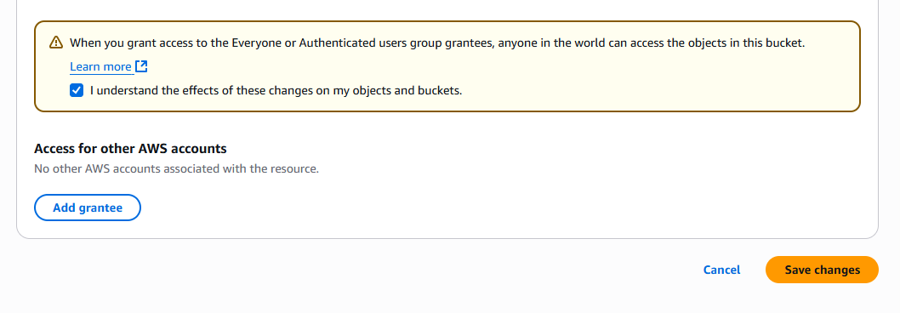

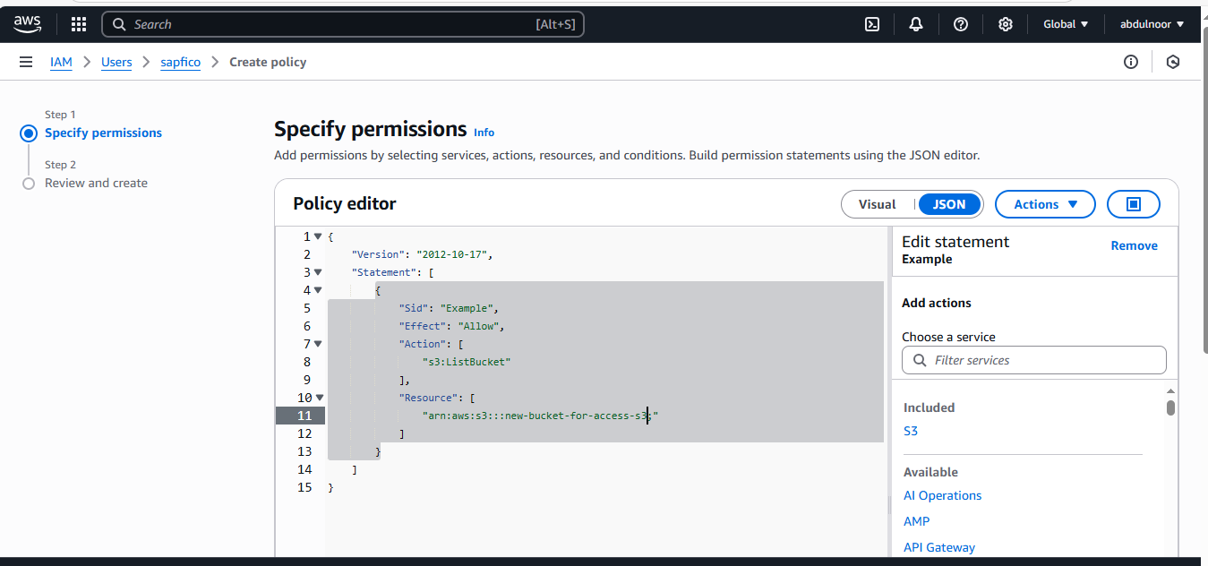

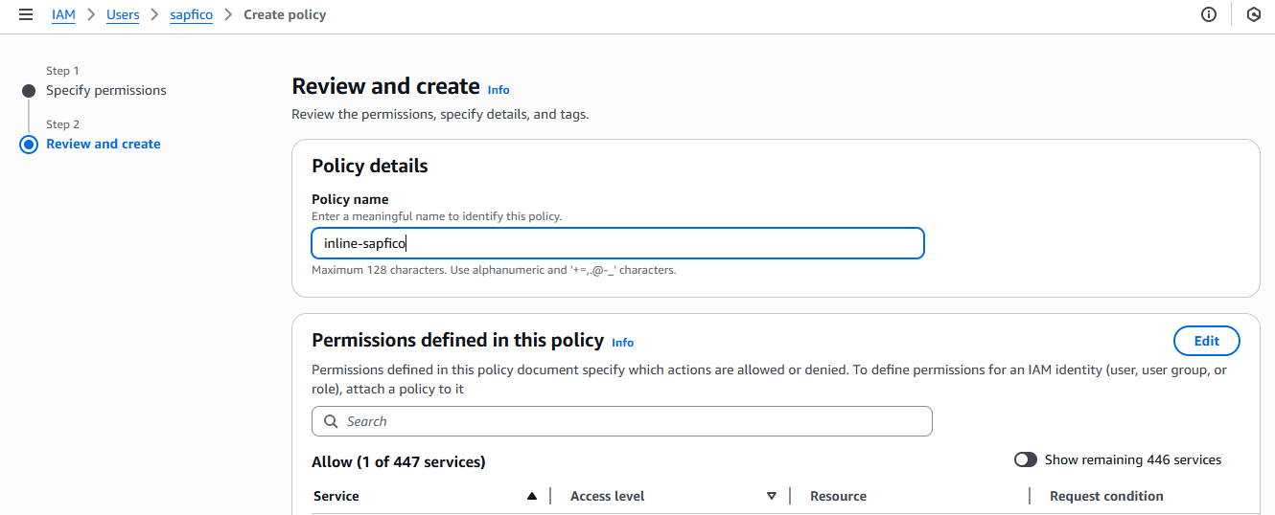

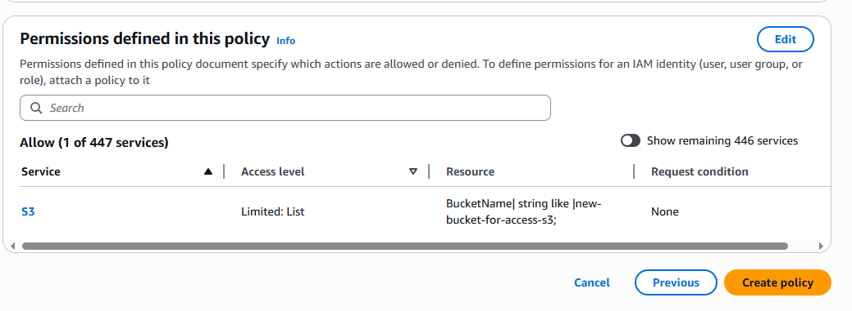

1. Create s3 bucket and upload some objects to s3.

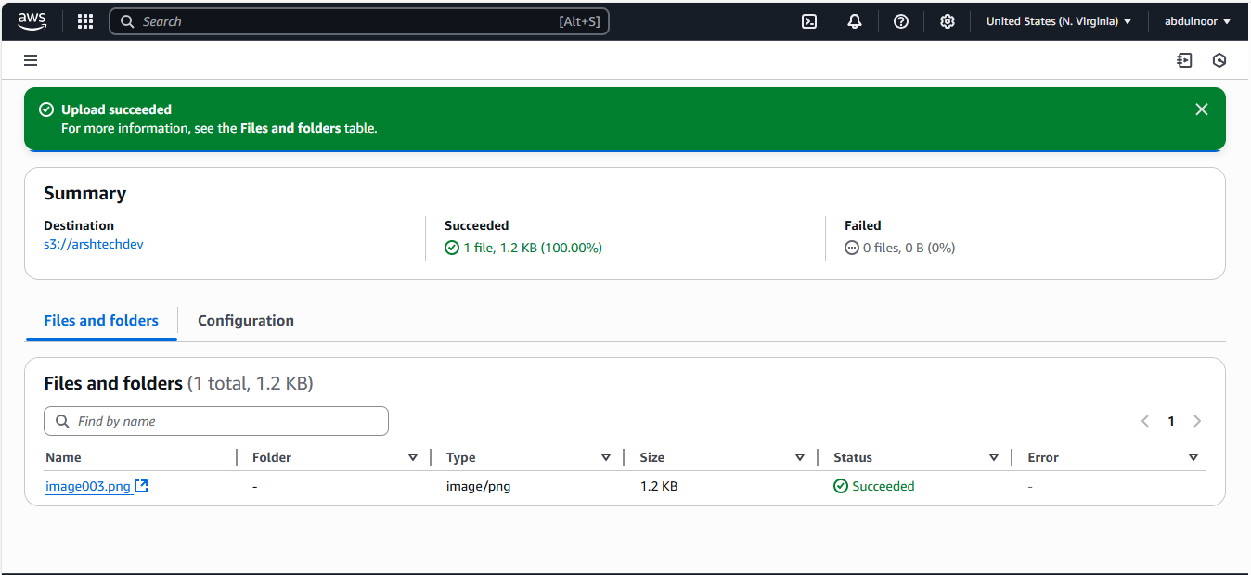

2) Deploy static website in s3 bucket.

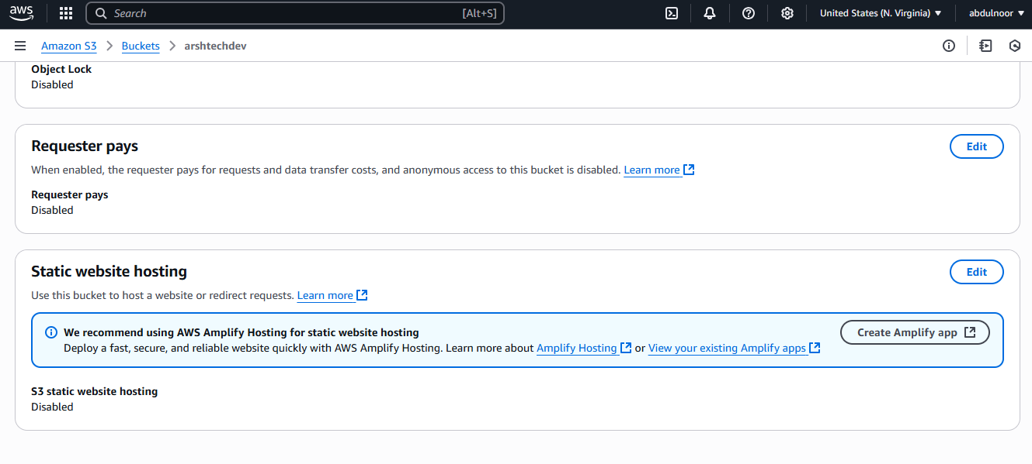

Click on edit of static website

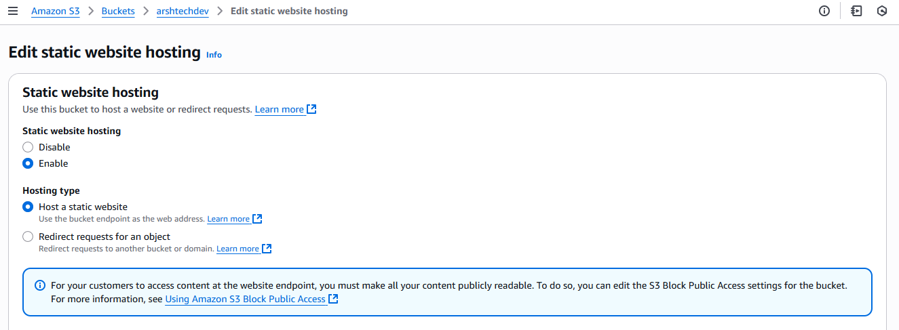

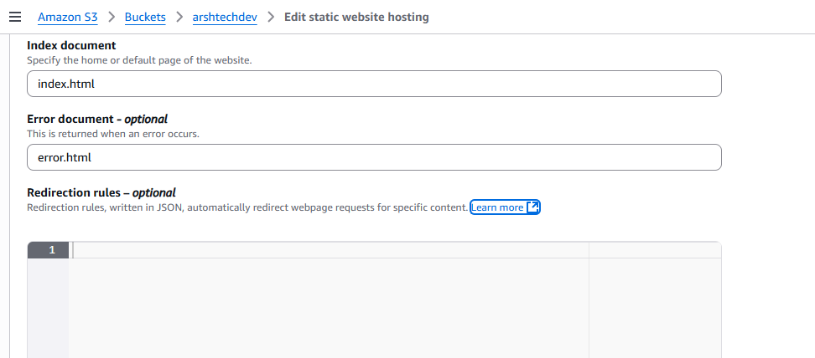

Save changes

Create 2 files

Index.html

Error.html



Wrote

Hello world devops

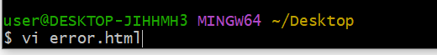

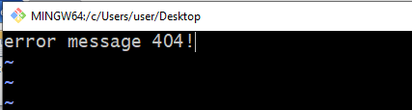

Upload the above 2 files in the bucket

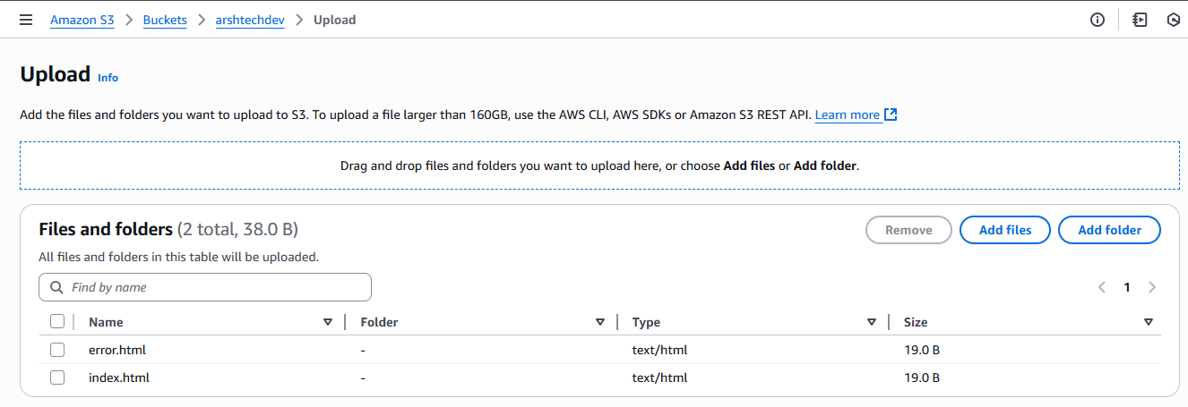

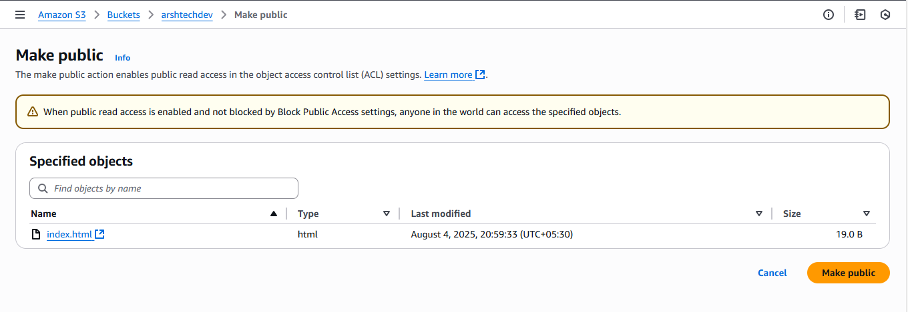

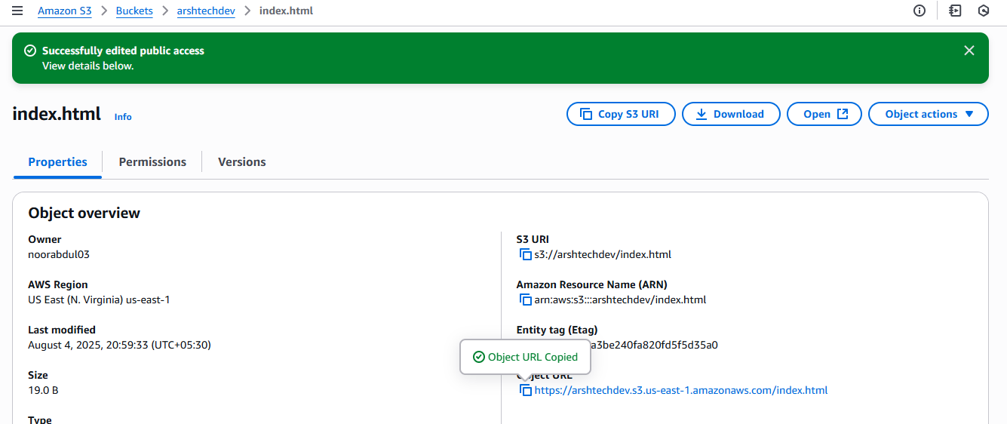

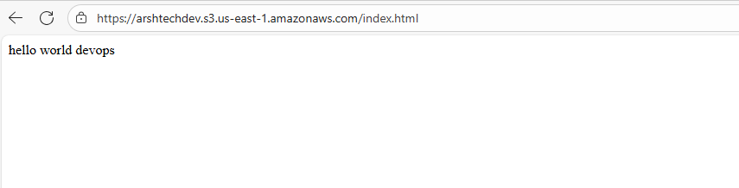if you delete the index.html ile then it will show the error message

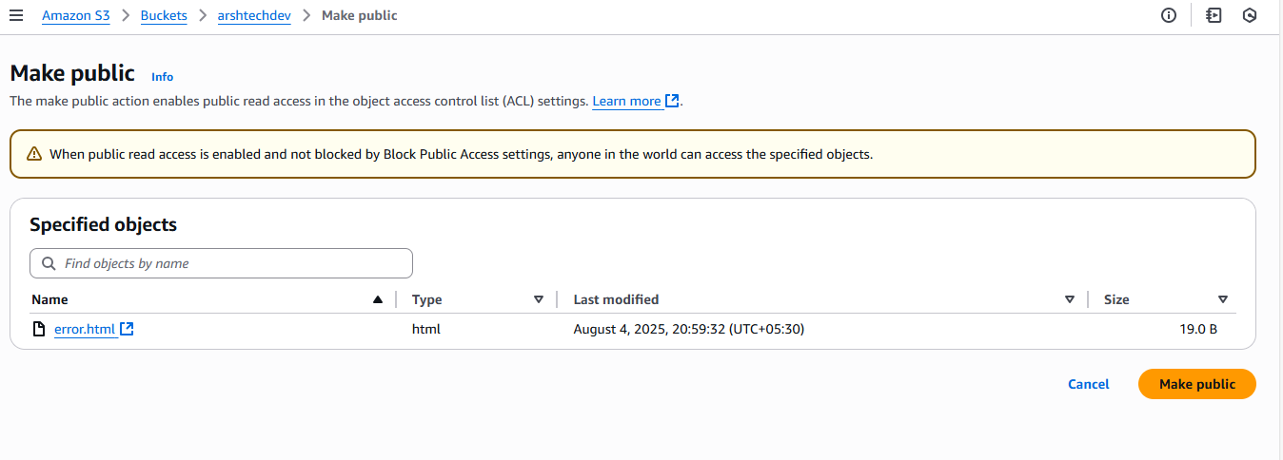

Use the below to check in the browser for two files

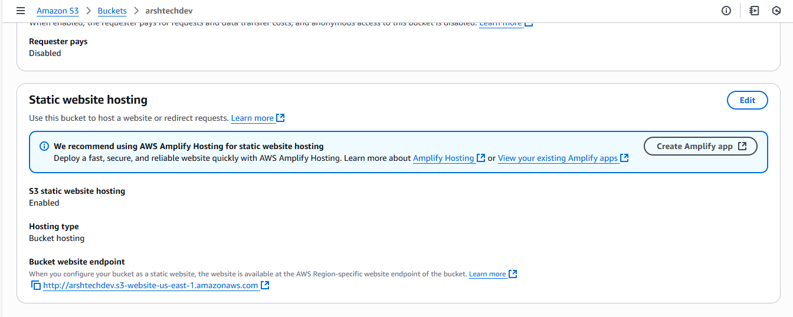

3)Enable cross region replication on s3 buckets.

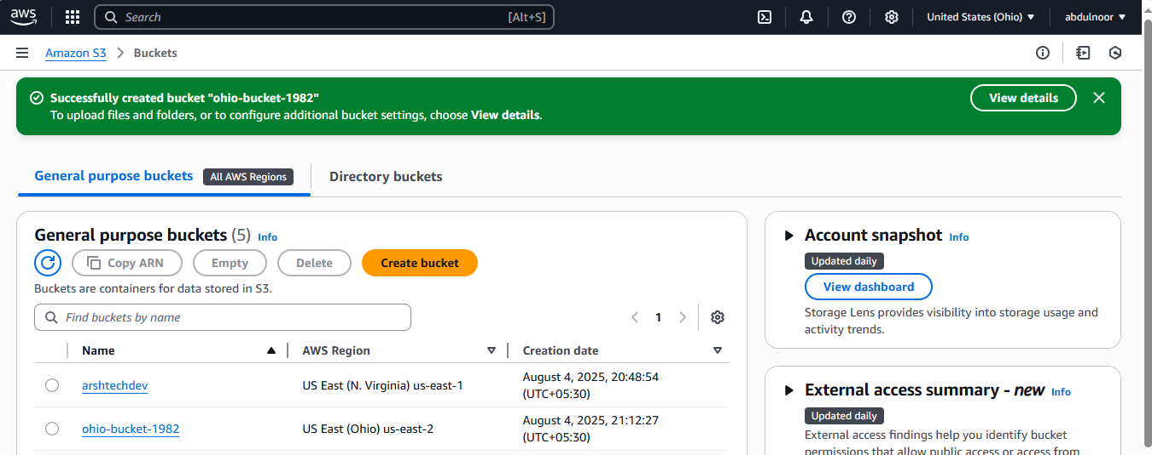

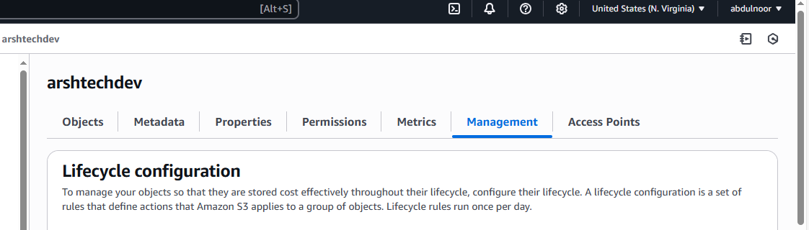

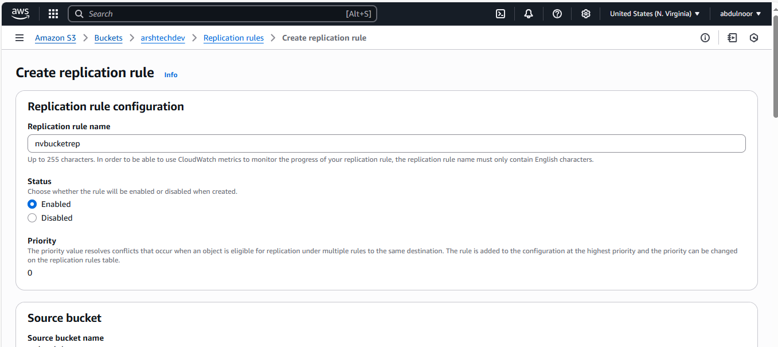

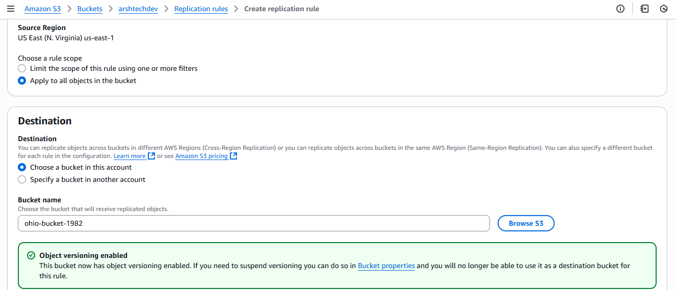

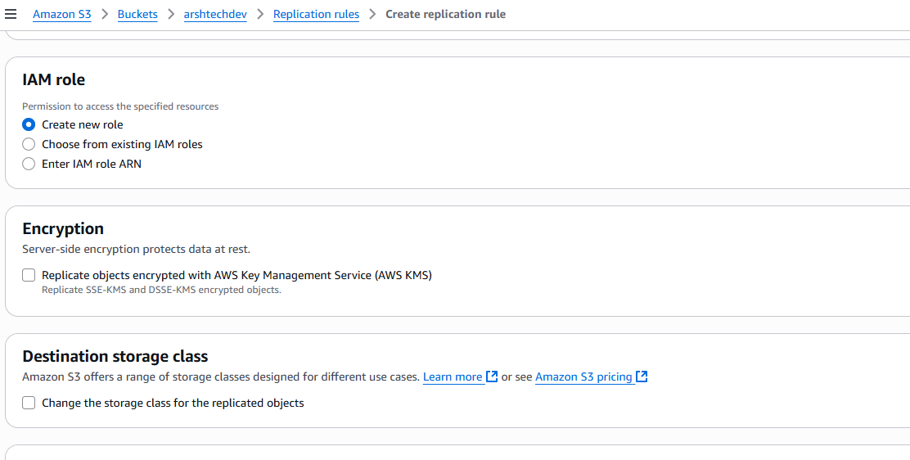

Save

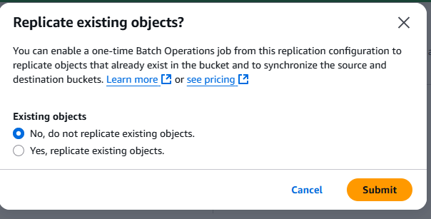

You can keep yes also

Upload any ile or image any inth eabove bucket

